CCNPv7 ROUTE

Chapter 1 Lab 1-1, Basic RIPng and Default Gateway Configuration
Topology

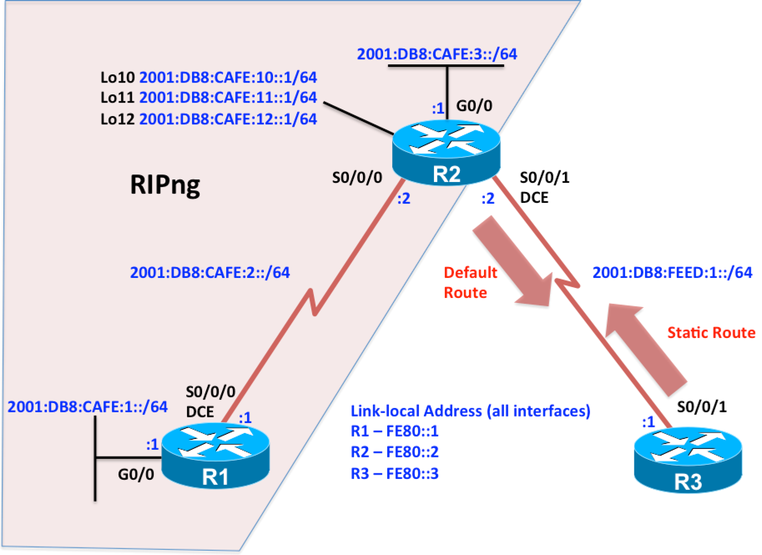
Objectives
- Configure IPv6 addressing.
- Configure and verify RIPng on R1 and R2.
- Configure IPv6 static routes between R2 and R3.
- Propagate a default route using RIPng.
- Examine the RIP process and RIP database.

Background
In this lab you will be configuring a new network to connect a company’s Engineering, Marketing, and Accounting departments using IPv6 and RIPng on two routers. You will also be configuring IPv6 static routing between the company’s gateway router (R2) and an ISP (R3). The gateway router will propagate the IPv6 default route via RIPng. Your task is to configure RIPng to enable full connectivity between all routers.
Note: This lab uses Cisco 1941 routers with Cisco IOS Release 15.4 with IP Base. The switches are Cisco WS-C2960-24TT-L with Fast Ethernet interfaces, therefore the router will use routing metrics associated with a 100 Mb/s interface. Depending on the router or switch model and Cisco IOS Software version, the commands available and output produced might vary from what is shown in this lab.

Required Resources
- 3 routers (Cisco IOS Release 15.2 or comparable)
- 2 switches (LAN interfaces)
- Serial and Ethernet cables
Step 0: Suggested starting configurations.
- Apply the following configuration to each router along with the appropriate hostname. The exec-timeout 0 0 command should only be used in a lab environment.
Router(config)# no ip domain-lookup
Router(config)# line con 0
Router(config-line)# logging synchronous
Router(config-line)# exec-timeout 0 0
Step 1: Configure addressing and loopbacks.
- Using the addressing scheme in the diagram, apply IPv6 addresses to the Fast Ethernet interfaces and serial interfaces R1, R2, and R3. Then create Loopback1 on R1, Loopback2 on R2, and Loopback3 on R3 and address them according to the diagram.
R1(config)# interface GigabitEthernet 0/0
R1(config-if)# description Engineering Department
R1(config-if)# ipv6 address 2001:db8:cafe:1::1/64
R1(config-if)# ipv6 address fe80::1 link-local
R1(config-if)# no shutdown
R1(config-if)# exit
R1(config)# interface serial 0/0/0
R1(config-if)# description Serial link to R2
R1(config-if)# ipv6 address 2001:db8:cafe:2::1/64
R1(config-if)# ipv6 address fe80::1 link-local
R1(config-if)# clock rate 64000
R1(config-if)# no shutdown

R2(config)# interface GigabitEthernet 0/0
R2(config-if)# description Accounting Department
R2(config-if)# ipv6 address 2001:db8:cafe:3::1/64
R2(config-if)# ipv6 address fe80::2 link-local
R2(config-if)# no shutdown
R2(config-if)# exit
R2(config)# interface Loopback 10
R2(config-if)# description Marketing Department
R2(config-if)# ipv6 address 2001:db8:cafe:10::1/64
R2(config-if)# ipv6 address fe80::2 link-local
R2(config-if)# exit
R2(config)# interface Loopback 11
R2(config-if)# description Marketing Department
R2(config-if)# ipv6 address 2001:db8:cafe:11::1/64
R2(config-if)# ipv6 address fe80::2 link-local
R2(config-if)# exit
R2(config)# interface Loopback 12
R2(config-if)# description Marketing Department
R2(config-if)# ipv6 address 2001:db8:cafe:12::1/64
R2(config-if)# ipv6 address fe80::2 link-local
R2(config-if)# exit
R2(config)# interface Serial 0/0/0
R2(config-if)# description Serial link to R1
R2(config-if)# ipv6 address 2001:db8:cafe:2::2/64
R2(config-if)# ipv6 address fe80::2 link-local
R2(config-if)# no shutdown
R2(config-if)# exit
R2(config)# interface Serial 0/0/1
R2(config-if)# description Serial link to R3
R2(config-if)# ipv6 address 2001:db8:feed:1::2/64
R2(config-if)# ipv6 address fe80::2 link-local
R2(config-if)# clock rate 64000
R2(config-if)# no shutdown
R2(config-if)# exit

R3(config)# interface Serial 0/0/1
R3(config-if)# description Serial link to R2
R3(config-if)# ipv6 address 2001:db8:feed:1::1/64
R3(config-if)# ipv6 address fe80::3 link-local
R3(config-if)# no shutdown
Leave the switch in its default (blank) configuration. By default, all switch ports are in VLAN1 and are not administratively down.
Note: If the switch has been previously configured, erase the startup config, delete the vlan.dat file from flash memory, and reload the switch.
- Verify that the line protocol of each interface is up and that you can successfully ping across each link. You should see output similar to the following on each router.
R2# show ipv6 interface brief
GigabitEthernet0/0 [up/up]
FE80::2
2001:DB8:CAFE:3::1
Serial0/0/0 [up/up]
FE80::2
2001:DB8:CAFE:2::2
Serial0/0/1 [up/up]
FE80::2
2001:DB8:FEED:1::2
Loopback10 [up/up]
FE80::2
2001:DB8:CAFE:10::1
Loopback11 [up/up]
FE80::2
2001:DB8:CAFE:11::1
Loopback12 [up/up]
FE80::2
2001:DB8:CAFE:12::1
R2#
Step 2: Configure RIPng on R1 and R2.
- After you have implemented your addressing scheme, enable RIPng on R1 using the following commands in global configuration mode.
R1(config)# ipv6 router rip ROUTING-RIPng
% IPv6 routing not enabled
R1(config)# ipv6 unicast-routing
R1(config)# ipv6 router rip ROUTING-RIPng
R1(config-rtr)# exit
R1(config)# interface gigabitethernet 0/0
R1(config-if)# ipv6 rip ROUTING-RIPng enable
R1(config-if)# exit
R1(config)# interface serial 0/0/0
R1(config-if)# ipv6 rip ROUTING-RIPng enable
Notice that IPv6 routing must be enabled prior to configuring RIPng using the ipv6 unicast-routing command. The network statement has been eliminated in RIPng. RIPng routing is enabled at the interface level instead, and is identified by a locally significant process name as multiple processes can be created with RIPng.

- Configure RIPng on R2 using the following commands.
R2(config)# ipv6 unicast-routing
R2(config)# interface serial 0/0/0
R2(config-if)# ipv6 rip ROUTING-RIPng enable
R2(config-if)# exit
R2(config)# interface gigabitEthernet 0/0
R2(config-if)# ipv6 rip ROUTING-RIPng enable
R2(config-if)# exit
R2(config)# interface loopback 10
R2(config-if)# ipv6 rip ROUTING-RIPng enable
R2(config-if)# exit
R2(config)# interface loopback 11
R2(config-if)# ipv6 rip ROUTING-RIPng enable
R2(config-if)# exit
R2(config)# interface loopback 12
R2(config-if)# ipv6 rip ROUTING-RIPng enable
As shown on R2, the RIPng process can be configured on the interface without first configuring the RIPng process in global configuration mode. The RIPng process will automatically be created if it doesn’t already exist.
Step 3: Verify the RIPng configuration.
- Verify that the RIPng process is running on R2.
R2# show ipv6 protocols
IPv6 Routing Protocol is "connected"
IPv6 Routing Protocol is "application"
IPv6 Routing Protocol is "ND"
IPv6 Routing Protocol is "rip ROUTING-RIPng"
Interfaces:
Loopback12
Loopback11
Loopback10
GigabitEthernet0/0
Serial0/0/0
Redistribution:
None
R2#
Which interfaces are involved in the RIPng routing process on router R2?

Which active interface(s) are NOT involved in the RIPng routing process on router R2?

- Use the show ipv6 route command to view R1’s IPv6 routing table.
R1#show ipv6 route
IPv6 Routing Table - default - 9 entries
Codes: C - Connected, L - Local, S - Static, U - Per-user Static route
B - BGP, R - RIP, I1 - ISIS L1, I2 - ISIS L2
IA - ISIS interarea, IS - ISIS summary, D - EIGRP, EX - EIGRP external
ND - ND Default, NDp - ND Prefix, DCE - Destination, NDr - Redirect
O - OSPF Intra, OI - OSPF Inter, OE1 - OSPF ext 1, OE2 - OSPF ext 2
ON1 - OSPF NSSA ext 1, ON2 - OSPF NSSA ext 2, a - Application
C 2001:DB8:CAFE:1::/64 [0/0]
via GigabitEthernet0/0, directly connected
L 2001:DB8:CAFE:1::1/128 [0/0]
via GigabitEthernet0/0, receive
C 2001:DB8:CAFE:2::/64 [0/0]
via Serial0/0/0, directly connected
L 2001:DB8:CAFE:2::1/128 [0/0]
via Serial0/0/0, receive
R 2001:DB8:CAFE:3::/64 [120/2]
via FE80::2, Serial0/0/0
R 2001:DB8:CAFE:10::/64 [120/2]
via FE80::2, Serial0/0/0
R 2001:DB8:CAFE:11::/64 [120/2]
via FE80::2, Serial0/0/0
R 2001:DB8:CAFE:12::/64 [120/2]
via FE80::2, Serial0/0/0
L FF00::/8 [0/0]
via Null0, receive
R1#

What is the next-hop address and the type of IPv6 address for the RIPng routes on R1?

- Ping the following remote addresses 2001:db8:cafe:3::1, 2001:db8:cafe:10::1, and 2001:db8:feed:1::1.
Which pings were successful and which were not? If there were any pings that were unsuccessful, explain the reason why.

Step 4: Configure IPv6 static routing between R2 and R3.
- Configure an IPv6 static route on R3 forwarding all packets for the 2001:DB8:CAFE::/48 prefix to R2.
R3(config)# ipv6 unicast-routing
R3(config)# ipv6 route 2001:db8:cafe::/48 2001:db8:feed:1::2

Note: The ipv6 unicast-routing command is required for a router to forward IPv6 packets, however IPv6 static routes can be configured without this command and forwarding IPv6 packets will be successful. However, it is suggested to use the ipv6 unicast-routing command.

- Configure an IPv6 default static route on R2, forwarding packets to R3. Propagate the default route to other RIPng routers in addition to other routes in R2’s routing table.
R2(config)# ipv6 route ::/0 2001:db8:feed:1::1
Step 5: Propagate the default route along with other routes via RIPng and verify.
- Propagate the default route to other RIPng routers in addition to other routes in R2’s routing table.
R2(config)# interface serial 0/0/0
R2(config-if)# ipv6 rip ROUTING-RIPng default-information originate
The originate keyword propagates the default route in addition to other routes in R2’s routing table.
- Display the RIPng routes in R1’s IPv6 routing table. Verify that R1 is receiving both an IPv6 default route and other routes from R2 via RIPng.
R1# show ipv6 route rip
IPv6 Routing Table - default - 10 entries
Codes: C - Connected, L - Local, S - Static, U - Per-user Static route
B - BGP, R - RIP, I1 - ISIS L1, I2 - ISIS L2
IA - ISIS interarea, IS - ISIS summary, D - EIGRP, EX - EIGRP external
ND - ND Default, NDp - ND Prefix, DCE - Destination, NDr - Redirect
O - OSPF Intra, OI - OSPF Inter, OE1 - OSPF ext 1, OE2 - OSPF ext 2
ON1 - OSPF NSSA ext 1, ON2 - OSPF NSSA ext 2, a - Application
R ::/0 [120/2]
via FE80::2, Serial0/0/0
R 2001:DB8:CAFE:3::/64 [120/2]
via FE80::2, Serial0/0/0
R 2001:DB8:CAFE:10::/64 [120/2]
via FE80::2, Serial0/0/0
R 2001:DB8:CAFE:11::/64 [120/2]
via FE80::2, Serial0/0/0
R 2001:DB8:CAFE:12::/64 [120/2]
via FE80::2, Serial0/0/0
R1#

What is the RIPng hop count for the default and other routes? Explain how the hop count is determined.

- To check whether you have full connectivity, from R1 ping the interfaces on R2 and R3. If you have successfully pinged all the remote interfaces, congratulations! You have configured RIPng including a default route.
Step 6: Propagate only the default route via RIPng and verify.
- Remove the previous command that propagates the default route using the originate keyword and replace it with the same command using the only keyword.
R2(config)# interface serial 0/0/0
R2(config-if)# no ipv6 rip ROUTING-RIPng default-information originate
R2(config-if)# ipv6 rip ROUTING-RIPng default-information only
- Display the RIPng routes in R1’s IPv6 routing table. Verify that R1 is only receiving an IPv6 default route from R2 via RIPng. You will need to wait for the routes to expire on R1 or issue the clear ipv6 rip ROUTING-RIPng command to clear the RIPng databases on R1 and R2.
R1# clear ipv6 rip ROUTING-RIPng
R1# show ipv6 route rip
IPv6 Routing Table - default - 6 entries
Codes: C - Connected, L - Local, S - Static, U - Per-user Static route
B - BGP, R - RIP, I1 - ISIS L1, I2 - ISIS L2
IA - ISIS interarea, IS - ISIS summary, D - EIGRP, EX - EIGRP external
ND - ND Default, NDp - ND Prefix, DCE - Destination, NDr - Redirect
O - OSPF Intra, OI - OSPF Inter, OE1 - OSPF ext 1, OE2 - OSPF ext 2
ON1 - OSPF NSSA ext 1, ON2 - OSPF NSSA ext 2, a - Application
R ::/0 [120/2]
via FE80::2, Serial0/0/0
R1#

Step 7: Examine the RIPng process on R2.
- On R2, use the show ipv6 rip command to display the RIPng process.
R2# show ipv6 rip
RIP process "ROUTING-RIPng", port 521, multicast-group FF02::9, pid 240
Administrative distance is 120. Maximum paths is 16
Updates every 30 seconds, expire after 180
Holddown lasts 0 seconds, garbage collect after 120
Split horizon is on; poison reverse is off
Default routes are generated
Periodic updates 338, trigger updates 5
Full Advertisement 0, Delayed Events 0
Interfaces:
Loopback12
Loopback11
Loopback10
GigabitEthernet0/0
Serial0/0/0
Redistribution:
None
R2#

How many RIPng processes are running on R2 and what are the process names?

What port number does RIPng use?

What destination address and type of address does RIPng use to send updates?

Step 8: Examine the RIPng database and next-hops on R2.
- On R2, examine the RIPng database.
R2# show ipv6 rip database
RIP process "ROUTING-RIPng", local RIB
2001:DB8:CAFE:1::/64, metric 2, installed
Serial0/0/0/FE80::1, expires in 171 secs
2001:DB8:CAFE:2::/64, metric 2
Serial0/0/0/FE80::1, expires in 171 secs
R2#

How many entries are in the RIP database?

Which entry is installed in the IPv6 routing table and why is the other route not included?

What is the next-hop IPv6 address and exit-interface of both RIP database entries?

What happens when “expires in n seconds” reaches 0? What keeps this value from expiring?

- On R2, examine the number of next-hops for the RIPng process.
R2# show ipv6 rip ROUTING-RIPng next-hops
RIP process "ROUTING-RIPng", Next Hops
FE80::1/Serial0/0/0 [2 paths]
R2#

Why are there two paths from the next-hop FE80::1/Serial0/0/0 but only one route in the IPv6 routing table using the next-hop FE80::1?

